3D Bioprinting Aboard the International Space Station using the Techshot BioFabrication Facility

Carlos C. Chang, PhD and Eugene D. Boland, Ph.D.*

*Corresponding author at Techshot, Inc., Greenville, IN 47124

# Introduction

While 3D bioprinting technology has advanced considerably, scientists struggle to overcome the challenge of fabricating complex networks of tiny void spaces found in organs, such as interconnected networks of capillaries. Conventional 3D bioprinting relies on the use of hydrogels as a means of growing new tissue from existing patient cells. Hydrogels are typically printed at refrigerated or ambient temperatures to maintain a relatively low apparent viscosity. Later, during the culturing of the tissue, the temperature of the hydrogel is raised causing physical crosslinking thereby increasing the viscosity considerably. Under Earth’s gravity, the initial low viscosity hydrogels lack the ability to maintain their shape, often creating puddles on the print surface. Scaffolding materials or other support structures are required to form these low viscosity materials into desired tissue-like shapes. Most conventional scaffolding is not designed to support the smaller and more complex shapes found in vascular or lymph node pathways. Scientists have also explored crosslinking polymers within the hydrogel to guide new tissue growth. However, those crosslinking agents that can work within the time frame needed to successfully guide tissue growth have proven toxic at worst or an impediment to cell migration at best.

The BioFabrication Facility (BFF) is the first 3D bioprinter installed and operated on the International Space Station that is capable of precision printing and culturing. The BFF is part of a larger plan to manufacture complex tissue-like structures in microgravity, with long-term goals of fabricating organs in space. Microgravity provides a unique third solution to printing complex organ structures, as minimal gravity removes the need for scaffolding structures to support complex tissue shapes. The BFF is a platform for researchers to print organ-like tissues and begin proving viability for human organ fabrication in space. BFF is used in conjunction with existing Techshot bioreactor cassettes, which hold the printed tissues for several weeks after initial printing, allowing the tissues to cohesively form on a cellular level. During this incubation period, the cassettes are housed inside the Techshot Advanced Space Experiment Processor (ADSEP). In time, the BFF payload could become a part of a larger system capable of manufacturing whole, fully-functioning human organs from existing patient cells to reduce the burden of organ shortages for transplant.

***3D bioprinting in Microgravity***

3D bioprinting in microgravity presents a number of unique challenges compared to typical terrestrial operation. Discussion of these additional considerations have been broken up into four subcategories: 1. Pre-flight Activities, 2. Launch Considerations, 3. In Flight Operations, 4. Return to Earth.

# Pre-Flight Activities

## BFF configuration

The Techshot BFF has its origin as a flybilized (term coined for the adaptation of terrestrial hardware for use in microgravity) quad-head 3Dn BioAssembly Tool developed by nScrypt, Inc. (Orlando, FL). To reduce acceleration loads on the construct during printing, a gantry platform (3-axis motion is applied to head rather than printing platform) with precision linear motors was developed. The linear drives have a resolution of 100nm, repeatability of 500nm and accuracy of 1 micron to assure printing detail at a physiologically significant size. This motion control system features high velocity drives with a large print area. The Z-axis has 50mm travel and velocities of greater than 400mm/sec from a single motor. The Y-axis has dual motors and is capable of greater than 750mm/sec while supporting the full gantry with 140mm of travel. The X-axis is also capable of greater than 750mm/sec and has a varying range of motion depending on the number of print heads used. With a single head, it possesses a maximum travel of 180mm but with all 4 heads, the range is limited to a maximum of 105mm (single head – 180mm x 140mm x 50mm; quad head – 105mm x 140 x 50mm). As the printheads are arranged along the X-axis, range is determined by the region where all pumps can overlap the same point allowing for full dispensing capability. To limit imparted vibration and motion artifacts, the drives are limited to 0.5xG acceleration although each is capable of higher values. Filtered and humidified air is circulated within the print volume to maintain a consistent environment for hydrogel printing.

Dispensing is controlled by 4 nScrypt Model 100, Generation two SmartPumps. These digitally controlled microdispensers operate through positive pressure and patented valving to enable near-perfect starts and stops without over extrusion (drips) or under extrusion (voids). The pumps can handle materials from 1 centipoise (cP) to over 1 million cP with inks that contain cells, flake loaded pastes or simple hydrogels. Volumes as low as 100 picolitres can be dispensed and line widths as small as 20 microns can be printed through a variety of nTip ceramic cones or blunt needles. Material is fed into the SmartPumps through a Luer fitting in the valve body connected to a gas driven dispensing syringe. For typical operations, a 10ml volume is chosen and held within a cooled bracket on the face of the pump. The print chamber is illustrated in Figure 1 (original BFF version without thermal control of the SmartPumps).

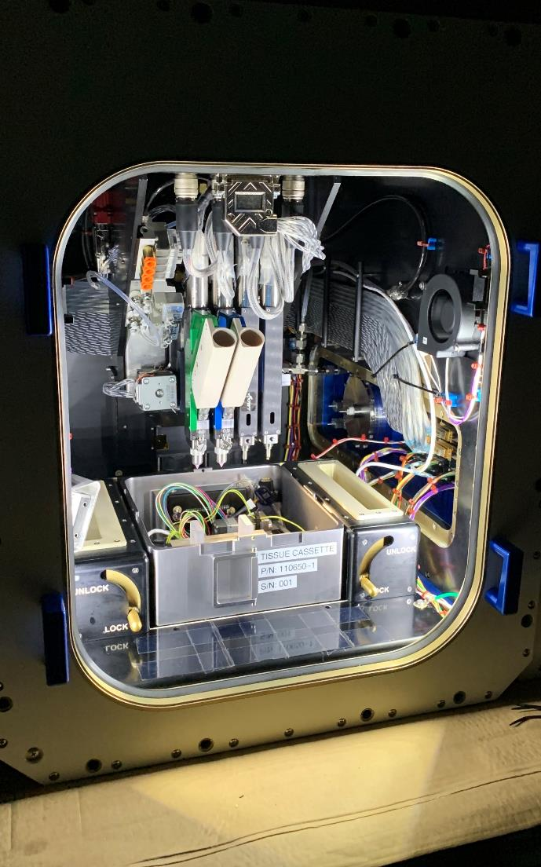

***Figure 1.*** *Interior of the Techshot BioFabrication Facility print volume. Two syringe holders are mounted on the face of the left-most SmartPumps and a bioreactor cassette is installed to receive the printed construct.*

Our team likes to share a story about when a pancake is a pancake to explain bioprinting. The pancake batter is much like the bioink. All the necessary components are present, but no one wants a pile of batter on their plate. Batter must be cooked to reach its optimal properties like a printed construct must be conditioned to reach biological significance. This is where BFF starts to differentiate itself from other bioprinters whether in space or in terrestrial applications. To call our conditioning chamber a bioreactor may be an understatement as many people equate bioreactors with large stirred vessels for amplifying cell cultures. Techshot’s system provides queues much like stem and progenitor cells receive in the womb. These signals are thermal, chemical, mechanical and electrical and the proper balance, timing and intensity of these signals will coax the printed cells, proteins, growth factors and other nutrients to fuse into a cohesive solid. This solid could be as simple as a tissue-analog monoculture or as complex as a neo-organ.

## Bioink Development

Months to years of planning go into each BFF experiment. The BFF system itself is outfitted with four independently controlled dispensing systems (referred to as SmartPumps). Planning begins by determining the number of SmartPumps that will be used and how many hydrogels (referred to as Bioinks) will be utilized to fabricate the structures of interest.

Bioinks tend to be cell specific, containing both viable cells and cell specific extracellular matrix (ECM) components to support cell development. For our experiments, we were interested in fabricating cardiac tissue-like structures utilizing 4 bioinks. The first three bioinks contained cells and ECM specific to cardiac, nerve, and vascular components. The fourth bioink was an acellular dissolvable hydrogel used to assist construct shape.

The cell specific bioinks were each made with decellularized tissue (Figure 2). Tissues were aseptically minced, decellularized, and then treated with peracetic acid for viral inactivation. Tissue samples were then frozen, lyophilized, and cryomilled to a fine powder. The powder was further digested via enzymes, neutralized, and finally reconstituted into a hydrogel at concentrations between 3 and 6mg ECM per ml.

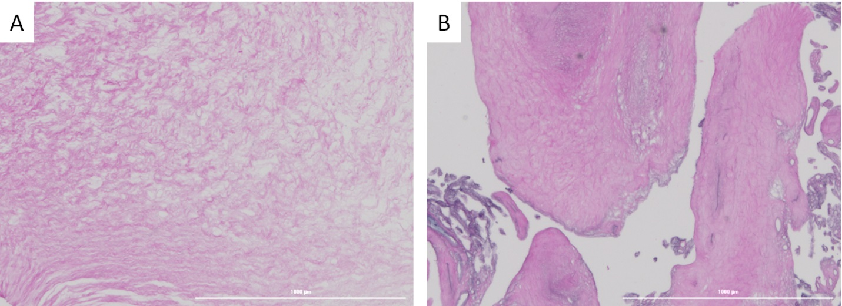

***Figure 2.*** *Images of decellularized human tissue sections. Hematoxylin and Eosin (H&E) stained human umbilical cord (A) and placenta (B) tissues were decellularized and treated to remove any remaining viral or bacterial material within the tissue. The pink color illustrates the maintenance of protein structure within the processed tissue. The lack of dark-stained nuclei within the samples suggests efficient removal of cellular nucleic material. Scale bar in both images is 1000um.*

For bioprinting activities, the hydrogel materials must meet a few requirements. First and foremost, the hydrogels must support cellular growth and development. Ground experiments were conducted to verify the hydrogels supported cell growth. Each cell type was cultured within its cell-specific hydrogel. Cells were first cultured in ideal conditions; hydrogels were suspended with the hydrogels, polymerized, and cultured within well plates in standard tissue culture incubators. Following successful culture, cells were then incorporated into bioinks and loaded into the bioprinter for dispensing into simple patterns. Those patterns were again polymerized and cultured within standard tissue culture incubators.

Just prior to the printed culture evaluations, Hydrogel polymerization time and viscosity were evaluated. Hydrogels were mixed and their polymerization rates were evaluated at different temperatures. In particular, we investigated polymerization rates at 4°C and 20°C. Looking forward to on-station activities, these were two temperatures of focus. The acellular ink component was planned to be stored at 4°C. Once mixed with the cells, there would be a slow increase of the ink temperature to 20°C- the operational temperature of BFF. In preliminary studies, Figure 3., it was important to determine the amount of time that the mixed hydrogels would be stable, maintaining a low viscosity compatible with dispensing at 20°C.

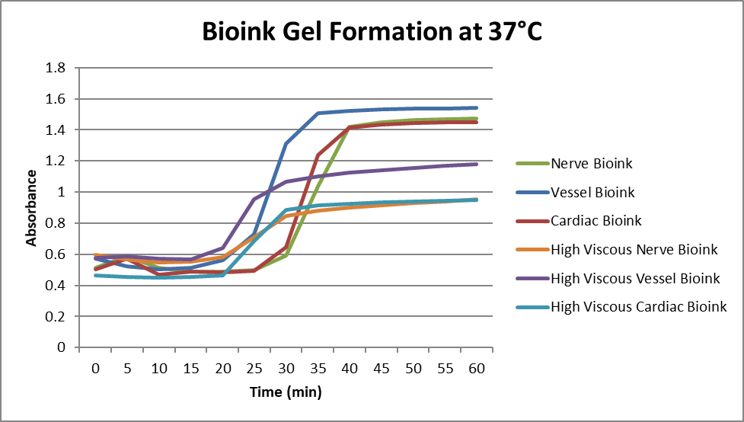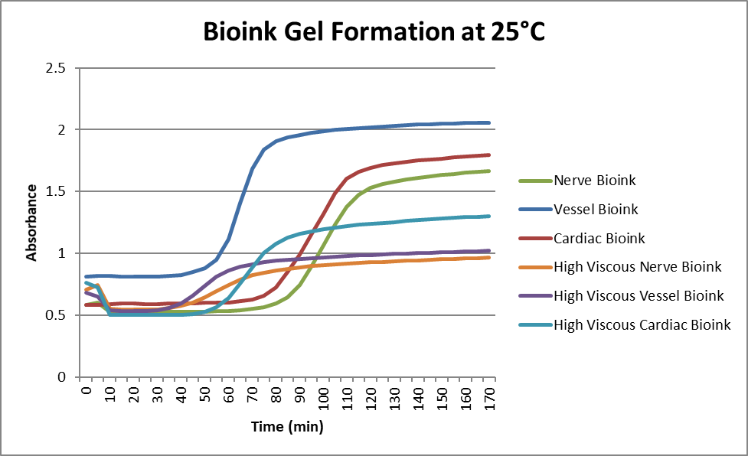

***Figure 3.*** *Hydrogel tests – viscosity vs time and temp for six variations of bioinks without exogenous cross-linkers*

## Print Testing

To reduce cost and validate concepts during the development of a future ISS payload, alternate methods of obtaining short durations of microgravity are available to a researcher. One such available method, which was chosen by the Techshot-led space bioprinter team, was a parabolic flight provided by the commercial company Zero-G. During the parabolic flight, Zero-G is capable of producing a microgravity environment for 20 to 30 seconds as the specialized aircraft reaches the apex of its parabolic ascent. This maneuver is repeated up to 24 times which allowed sufficient print time and repetition to be a platform suitable to conduct the experimental printing of human tissue in a microgravity environment.

To complete this, Techshot partnered with nScrypt, an Orlando, FL based Digital Manufacturing company, to modify a commercial off the shelf (COTS) gel printer into a configuration amenable to printing a cell suspension material in a microgravity environment. In addition to the engineering effort to meet the physical constraints and requirements of a microgravity flight, printing processes and controls unique to the space environment were developed. Upon completion of this effort, the first biological printer designed to print in a microgravity environment had been developed and readied for flight.

In June of 2016 Techshot flew the first bioprinter on a Zero-G parabolic flight from Orlando, FL and printed the first neonatal heart ventricle using adult human stem cells. During this flight various geometries to replicate vascular structures were printed with gels containing suspensions of human cells. The gel viscosities used to fabricate these vascular structures could only be printed in a microgravity environment as the mass and intricacy of the structure would collapse when subjected to a 1 g environment. Successful printing of these structures proved the viability and capability of the technology for longer term microgravity research available on the ISS.

Ground breaking biological goals accomplished through this research include: optimization of gel viscosity for printing structures in microgravity, selection of cell size and type for tissue viability and printing of a nonviable neonatal sized heart (ventricles only). In addition to biological accomplishments, this research enabled the development of print processes and algorithms unique to fabricating gel-based structures in a microgravity environment as well as demonstrating surface-tension-based layer fusion not seen with typical ink viscosities when printing on the ground. Furthermore, the mechanical hardware developed to conduct printing on the parabolic flight formed the basis of payload that eventually flew to the International Space Station. is now positioned to take the next iterative step which is further refinement to become a payload facility for conducting research on the ISS. Additional process automation, cell-ink mixing, syringe installation and print assembly cleaning methods were needed to transfer a technical operation on the ground and parabolic flight to the time / training constraints of ISS operations.

Mostly due to the nature of the cyclic printing on the parabolic flight, a great deal of personnel interaction was required for each print. Looking forward to on-station activities, it was important to minimize the time and technical requirements to operate BFF. Modifications were made to syringe mixing of bioink components, syringe installation into BFF, and print assembly cleaning.

In development, ink components were measured with digital pipettes in a biosafety cabinet just prior to printing activities. On station, these typical “simple” operations are not logistically possible. Instead, we worked to prepare pre-loaded syringes of cells and ECM that could be connected. Safety considerations also required the incorporation of leak-proof connectors. Two revisions of connectors were incorporated into BFF.

The first set of connectors were stainless steel locking sleeve connectors with internal valves. During ground tests, the connectors were utilized in multiple successful test prints. In preliminary tests on station, a few issues were presented. The flow path through the connectors proved to provide too small of an internal opening and the tortuous path around spring-loaded valves led to higher resistance and sheer on the dispensed bioinks. The combination of these two issues caused clogging within BFF SmartPumps. In response to these issues, a second set of connectors were introduced. The second connectors were a simpler design. The internal fluid path diameter was much larger permitting lower resistance. In addition, the safety valves were internal and external silicone needleless septums, providing a fluid path of much lower resistance. There were far fewer clogging issues after changing to connector system 2.

Installation of the syringes into the BFF system was also streamlined. The first locking sleeve connectors did not present any issues during ground testing. However, on station, the sleeves would often not engage, delaying prints and preventing proper BFF operation. The change to the second connectors introduced quarter-turn Luer connectors that were much more reliable.

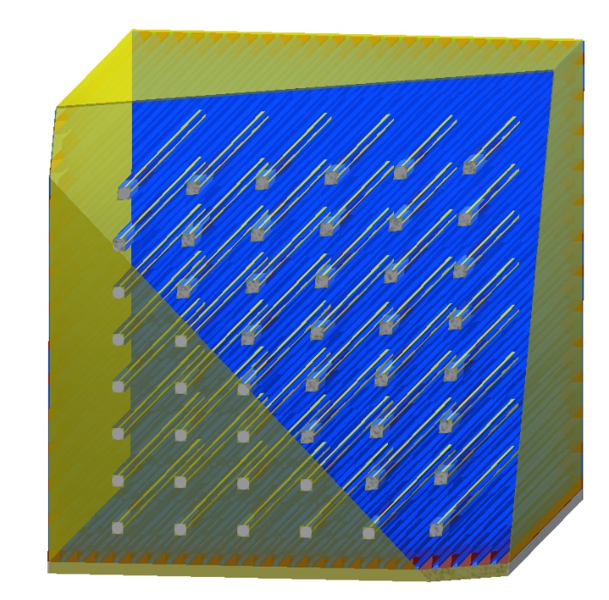

***Figure 4.*** *Cut-away view of tissue construct. Rods through the construct are sacrificial ink aligned to needle array within bioreactor chamber. Rods are wrapped in vascular cells / inks and nerve cells/inks. The bulk of the construct is cardiomyocyte ink/cells.*

Once installed, the business of the printer could be conducted. Our ISS printing activities were divided into two projects. The first project was the fabrication of a vascularized tissue-like construct. The second was the fabrication of a 3D meniscus-like structure. Both structures utilized all 4 SmartPumps and relied on materials with multiple viscosities.

The vascularized tissue construct, depicted in Figure 4., was designed as a rectangular prism containing an array of internal parallel channels. Each channel would be surrounded by vascular cells with cardiac and nerve cells distributed through the rest of the volume. Thinking about how materials would interact in the absence of gravity, in particular low viscosity hydrogels, surface interactions would be the dominant driving force of pattern structure. This thinking led to dedicating one bioink as a higher viscosity, degradable hydrogel. This “structural” hydrogel would be used to provide a 3D framework to shape the lower viscosity cell-suspended hydrogels. Once the cell-containing hydrogels polymerized, the structural hydrogel would be rinsed away.

In ground studies, we optimized the viscosity of the structural hydrogel to permit dispensing of an outer box to contain the low viscosity cellular bioinks. Print parameters were also optimized to permit the printing of freestanding channels within the structure (Figure 5). The internal channels served the two important purposes in the print. First, the additional internal surfaces provided guides to help the shape and direct flow of the low viscosity inks once they left the print tip. Secondly, once the cell containing hydrogels polymerized, these channels were made to dissolve, leaving behind an array of hollow channels to perfuse the surrounding developing construct (Figure 6).

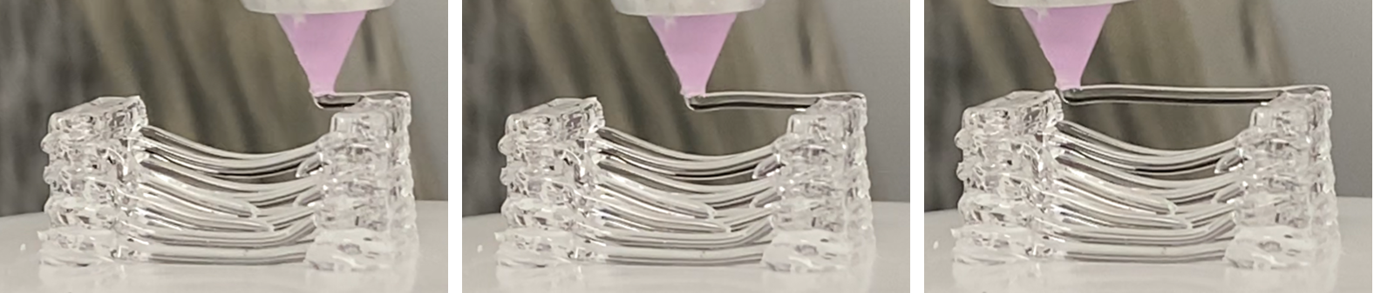

***Figure 5****. A collection of images illustrating the optimized dispensing of a free-standing channel of our high viscosity support hydrogel. This example shows a channel of approximately 300um spanning a distance of approximately 30mm.*

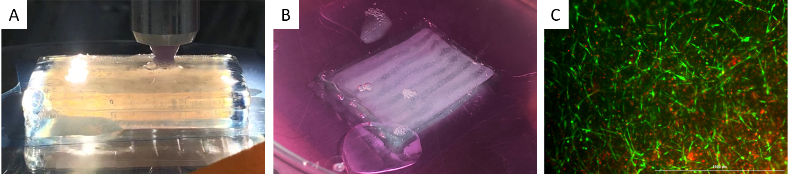

***Figure 6****. A) Image of ground printing of test vascular construct. As the low viscosity cell-containing hydrogels are printed, the high viscosity (clear) structural material maintains its shape permitting the hydrogels to polymerize. B) image of polymerized vascular construct after transfer to an incubator. The internal channels can be seen within the construct as the structural material is rinsed away. C) A representative image of vascular cells growing within the printed construct after 3 days of culture. Viable cells (green) are visibly extending out into the matrix, beginning the remodeling process. The scale bar is 300um.*

Dispensing of the low viscosity hydrogels was also scripted with a focus on surface interactions. To ensure materials left the print tip and remained within the pattern, the initiation of each low viscosity material started in a corner of the layer. In that way, material would immediately leave the print tip and contact at least two surfaces. These surfaces provided a large interface to help hold the hydrogel in place as additional material was added to the structure.

Although a great deal of focus was placed on developing hydrogels and optimizing printing, another key aspect of bioprinting also needed to be addressed, cleaning the print tips after a session. On the ground, SmartPumps are typically disassembled after each print run, components are soaked in a variety of solvents and sterilization fluids, permitted to dry, and then aseptically reassembled prior to the next run. On station, typical cleaning fluids such as 70% ethanol and acetone present too much of a safety risk to be used. In addition, disassembly and reassembly of each SmartPump presented too much of a logistical challenge to be feasibly incorporated into mission operations. New cleaning methods needed to be developed.

Ground evaluations were conducted to evaluate alternate cleaning solutions. Efforts focused on two different solvents, both approved for use onboard the ISS. First, investigations evaluated the use of benzalkonium chloride (BZK), a disinfectant with a history of use in past missions. BZK was found to be an effective solvent for cleaning the smart pump components and the flow path. However, during the first test prints in microgravity, it was found that over time, due to cohesion and surface wetting residual fluid remained in the flow path between prints. There was concern that this remaining fluid could negatively impact cell viability in subsequent prints. In response, cleaning fluids were changed to a 4% hydrogen peroxide solution. The new cleaning solution adequately cleared residual bioinks and disinfected the fluid path. As an added benefit, any residual fluid would break down into water and oxygen, posing a trivial threat to cell viability in subsequent print runs.

An additional concern with SmartPump cleaning was accommodating the waste cleaning fluid. Unlike in the lab, small disposable containers cannot be easily placed into and removed from the BFF print chamber for waste collection. Likewise, the low viscosity cleaning solutions present a few challenges. If permitted to simply eject from the print tip, the fluid could wet the print tips, forming large masses of fluid. Depending on printer movement, these fluid volumes could then dislodge and float within the print chamber – potentially becoming a safety and/or contamination concern. To avoid this scenario, each print cassette was designed with a dedicated waste port. This port contained a needless septum that created a seal around the print tip minimizing fluid leaks during dispensing. Once the tip was disengaged from the port, the septum then sealed preventing fluid from leaving the waste port.

# Launch Considerations.

In preparation for rocket launch, a great deal of energy went into selecting, evaluating, and testing component packaging. Coordinating with both NASA Safety and Operations teams, experiment components were organized to optimize efficient packing and sample grouping for on-station printing activities.

## Containers and Containment

A major overarching NASA safety requirement is the testing of all sample packaging to ensure no leaks occur. All samples are inspected prior to leaving our facility. They are inspected again at turnover to our NASA colleagues. Once delivered, all samples are inspected on the ISS prior to being stowed in their respective temperature-controlled areas.

For bioprinting activities, samples were contained within a number of different containers including multiple sizes and styles of syringes, gas permeable bags, and sterilization pouches. All syringes were pressure tested to ensure they could withstand the expected forces exerted during launch. Similarly, gas permeable bags (used to store medium) were both pressure-tested and evaluated to withstand puncture. To minimize contamination, all utilized materials were purchased presterilized (preferred) or sterilized prior to use. When possible, materials were autoclaved. However, most utilized polymers could not withstand 121°C without adverse material warping, melting, or cracking. These materials were typically gas sterilized via ethylene oxide exposure. We also took the extra step to gas sterilize all utilized sterilization pouches prior to packing any components for use.

## Bioink Packaging

On the ground, combining bioinks is a fairly standard procedure. Hydrogels are prepared ahead of time and are typically maintained in a refrigerator or within a biosafety cabinet, stored in an insulated container loaded with ice. Hydrogel components are maintained at 4°C until needed. Meanwhile, the cells of interest are retrieved from liquid nitrogen storage and then thawed for use. Once ice crystals are no longer visible, the cells are added to the base hydrogel. Once mixed, the cell-loaded hydrogel is transferred to a syringe and then installed in the bioprinter for use.

Onboard the ISS, this “simple” process is far more complicated. First, storage facilities are spread around the multi-module facility. For cooled samples, separate MELFI and GLACIER systems are utilized to maintain specimens between -160°C and +2°C. Typical operational temperatures are -95°C, -35°C, and +2°C. Each maintained by separate units that may be different modules within the ISS. Ambient temperature (20°C) storage areas are distributed throughout the ISS modules. From a logistics standpoint, one crew member is assigned to each experiment each day. Experiments often run in parallel, so their time is meticulously scheduled with minute resolution for their entire mission. It is extremely important to minimize the time required to set-up and execute each experiment.

With time management in mind, it was imperative to group as many like-temperature items together as possible. Minimizing the number of “kits” to be retrieved during experiment preparation. As part of the scheduled experiment prep-time, crew members float around station to collect all the items required for the experiment. Once gathered and placed in the work area, the experiment can begin.

For printing activities, all the cells (stored at -95°C) were packaged together for each run (3 frozen cell syringes per bag). Likewise, syringes of cold hydrogels were packaged together for storage at +2°C (4 hydrogel syringes per bag). Cells and hydrogels were all double bagged for shipment, providing 2 levels of containment in the event of a leak. With space and storage at a premium, we were permitted to send 2 extra sets of both cells kits and hydrogel kits. All of the other room temperature components were packaged together and maintained in standard ambient storage.

Due to limited space in the “powered” containers that transport temperature-controlled samples to the ISS, only the bare minimum of materials are permitted. For instance, a connector was required to attach each cell-syringe to the hydrogel-syringe, permitting mixing of the two components prior to use. To minimize contamination, the connectors were individually packaged within sterile pouches and grouped together in sets of three (corresponding to the three cell-containing bioinks of each print). The connectors and packaging would have increased the size of the overall packaging of the bioinks. As a result, this connector was included with the room-temperature components.

An additional interesting consideration of packaging is related to orientation during launch. Both SpaceX and Northrup Grumman rockets are loaded in a horizontal orientation, and then moved to a vertical orientation for launch. Depending on packaging, the potential for fluid separation, or mechanical components, packed items may need to be loaded onto the rocket considering the launch vector. In our systems, the print cartridges were packed so the print surface would be perpendicular to the launch vector.

# In Flight

In flight crew activities and how materials behave in microgravity provide a substantial impact on how experiments are organized. For example, many experiments that require the use of cell culturing start with a frozen cell vial that is thawed. On the ground, cells are transferred from liquid nitrogen storage and immediately thawed in a water bath. The cell vial may or may not be manually swirled for a few minutes until ice crystals are no longer visible. Cells are then transferred to a conical tube and gently reconstituted in medium. After a gentle mixing (often by a few conical tube inversions) the cells suspension is centrifuged, the extra medium is removed, and then cells are collected and added to their destined container or culture vessel for use.

On station, this process is far more complicated. Starting with frozen cells, there are safety requirements that prevent direct handling of extremely cold samples (typically below -35°C). For warming samples, there are no water baths on station. Samples are typically thawed by setting them out in an ambient space. For frozen cell samples in 3mL of freeze medium, this can take approximately 45 minutes. Cell and medium transfers all must be conducted within liquid-tight containment fields or boxes. The available centrifuge on station may be accessible, but the operation time is fairly long and also requiring repackaging of samples for transport to and from the instrument.

## Bioprinting Preparation

Past experience with planning experiments on the ISS informed how we approached sample preparation and loading of the BFF for on-station operations. Operations began the day before printing. Crewmembers placed a custom heating block in a 37°C incubator. This heating block was fabricated to accommodate three frozen cell syringes. In was found that the use of this heating block would thaw the cell samples in under 7minutes (far better than the 45minutes of ambient warming).

The morning of printing, crew members first expanded the outer containment bag fitted to the front of BFF. Once locked in place and ready to use, the crew member retrieved the frozen cell kit, cooled hydrogel syringe kit, ambient stored printing cassette, experiment kit bags, cleaning wipes, and the pre-warmed heat block from the. All items were placed inside the outer bag and sealed (Figure 7).

*Figure 7. Image of Astronaut Koch working with BFF during on-station operations.*

The first order of business was placing the frozen cells into the heat block. Cells thawed in the block as cleaning procedures were conducted – all exterior and surfaces of BFF were wiped down. In addition, the printing cassette was opened and locked into place. At this time, cells were checked to evaluate their thawing status. Once thawed, cell syringes were connected to the cold hydrogel ink syringes and slowly mixed. Care was taken to mix slowly to minimize shearing cells and also to minimize the formation of bubbles. Once mixed, the cell-loaded bioink syringes were loaded into BFF and quick visual and tug checks verified BFF was set-up and ready to print.

## Bioprinting in Microgravity

The entire bioink-dispensing process was controlled and monitored from our ground facility. BFF was designed with multiple cameras that permitted observation of print tip location. Each print session began with facility health and safety tests, camera checks, and operational tests of each pen tip. XYZ coordinates and dispensing were checked to ensure no anomalies had been introduced in the previous cleaning activities. Once positions and movement had been verified, print files were uploaded to the printer.

The printer was designed to run without the need for crewmember interaction. Once the outer door was closed, the facility was under our remote control. One of the most challenging aspects of microgravity printing was the need for perfection. On the ground, if a small error occurs in the beginning of a print such as an errant drop of ink falls from a print tip, a bubble in a support ink causes a pattern abnormality, maybe the ink is slow to dispense causing a pattern gap, the print can be stopped and the stage can be wiped. The print can be restarted. On station, with the limited crew time, crew safety concerns, and limited supplies that can be launched to station, errors and print restarts were not an option.

To play it safe, the entire printed construct was broken up into scripts of approximately 7-layer thicknesses. These built-in pauses would permit us to monitor how the materials were printing, permitting (if needed) minor modifications of print pressures, speeds, and position. In the rare occasion that some defect was noticed during the print, that could also be addressed before continuing with additional layers. Altogether, our cardiac construct was approximately 100 layers, fabricating a volume of approximately 31mm x 23mm x 27mm. Once printed, approximately 1 hour of time was set aside to permit polymerization of the print.

Scripts were designed and tested on the ground prior to use using a system that was nearly identical to the flight model. All printing components were identical between the two systems. We even built the ground system to be compatible with a video delay to mimic remote printing. From a preparation standpoint, procedures were in place and the printing activities had been worked out, tested, and ready for use. However, every print session was unique in one way that could not be easily predicted – loss of signal (LoS) timepoints during our assigned experiment time.

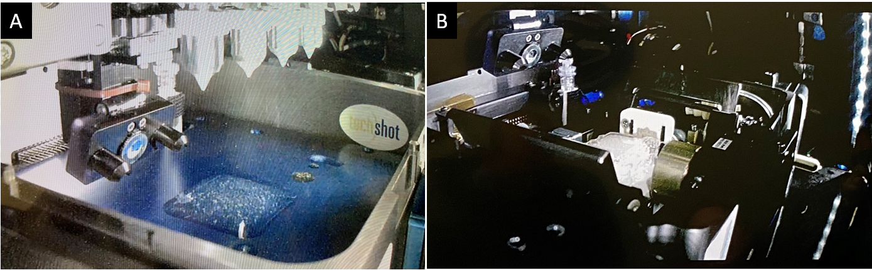

***Figure 8****. Example images of 3D bioprinted constructs on ISS utilizing the Techshot BioFabrication Facility (BFF). A) SpX-18 printing of low viscosity material. The printed structure exhibited a thickness of a few millimeters in the z-direction. B) SxP-19 printing of both low and higher viscosity bioinks. The higher viscosity inks were used to create a border, permitting the fabrication of thicker (~20mm) structures in the z-direction.*

Lasting anywhere from a few minutes to potentially an hour, LoS presented a major challenge to printing activities. The BFF system was designed to run prints autonomously. Once the print was loaded and started to run, BFF could complete the print without any need for user intervention. For safety purposes, we tried to minimize the time the printer would be active without our ability to monitor it remotely. It often led to creative organization of printer-setup and subsequent print loading and printing.

## Post-Print Activities and Conditioning

A unique aspect of our BFF system was the direct printing of our pattern into a bioreactor. Once bioprinting activities had completed and the print had time to polymerize, we relied on crew members for a number of crucial steps to complete the print activities. The bioreactor was designed for simple operation and access to all the port. First the lid was placed over the print then sealed. Next, media was slowly added to the bioreactor chamber and a few media lines were primed to remove air from the system (Figure 9). Due to the fragility of the newly printed construct, a crew member slowly added media to the sealed bioreactor volume. As it filled, some bubbles formed. We incorporate both a manual bubble retrieval tool and bubble traps within the media circulation system to remove bubbles from the system. Lastly, the bioprinting cassettes were removed from BFF and carefully loaded into our powered incubator system to support construct conditioning.

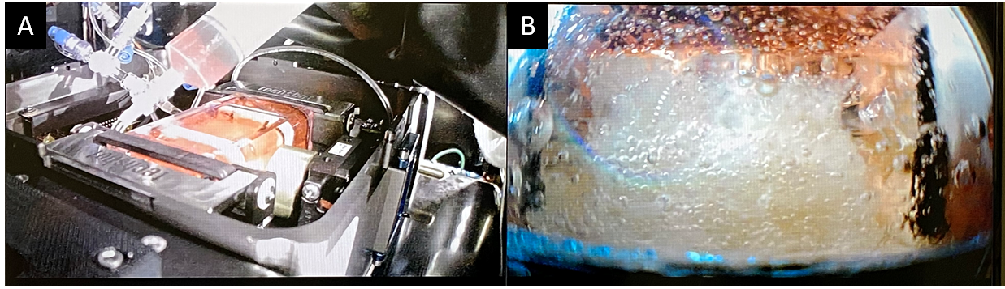

***Figure 9****. Images of Astronaut Koch filling the bioreactor with media following bioprinting (A). B) side image of sealed bioprinted construct following media addition.*

During the incubation time, media kits were prepared to replace spent media. Operations were coordinated to exchange media every 4 or 5 days during the 30-day mission. Crew members would access the print cartridge and replace the media.

# Return

Live return capability is provided in a custom rack which contains three cassettes and fits within the Microgravity Experiment Research Locker / Incubator (MERLIN). MERLIN controls the temperature to the ideal conditions and provides power to maintain feed / circulation pumps, physical conditioning (stretch) and electrical conditioning (pacing). After recovery at a NASA space center (typically the Kennedy Space Center for current SpaceX returns), the cassettes can be turned over to investigators or transported to either the Techshot facility or the PI’s facility within a thermally controlled potable incubator / refrigerator while maintaining internal power similar to the return on MERLIN. Because of the time constraints for culturing and conditioning, we typically work backward from return to schedule on-orbit operations. Additionally, chemical fixation and / or on orbit thermal preservation are also available if live return is not the end goal. This might be because mid-stage growth conditions are desired or prevention of any gravitational readaptation when the capsule returns.